Joint Call for Proposals
ERA-NET Cofund on Sustainable Crop Production
- SusCrop -
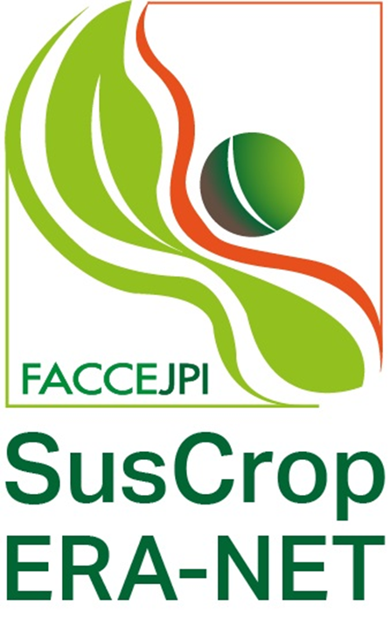
Deadline for submission of pre-proposals:
April 4, 2018, 13:00 h (CEST)

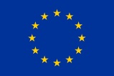
Pre-Proposal Template
published on January 17, 2018
This template, displaying the content of a pre-proposal, is provided for information/offline use only.
The submission must be done online via www.submission.suscrop.eu.

This project has received funding from the European Union’s Horizon 2020 research and innovation programme under grant agreement No 771134.
This project has received funding from the European Union’s Horizon 2020 research and innovation programme under grant agreement No 771134.

The Call invites proposals for collaborative research and innovation from transnational consortia of industry, SMEs, stakeholder associations and research organisations which are expected to make a significant impact on European crop research and production. Funding will support basic research and application-oriented activities, which will greatly improve coherence and generate stronger synergies in the thematic areas of sustainable and resilient crop production.
Partners will facilitate an active exchange of ideas, concepts and knowledge between participants from all relevant fields. This document announces the first transnational Call in the field of sustainable crop production, within the framework of the ERA-NET-Cofund on Sustainable Crop Production (SusCrop).
- The selection process consists of two phases. Invitation to the full proposal phase is subject to a positive recommendation of the pre-proposal.
- This template, presenting the structure and content of a pre-proposal, is provided for information/offline use only. In any case the submission must be done online via https://www.submission.suscrop.eu/ before the deadline April 4, 2018, 13:00h (CEST).
      - Pre-proposals must be submitted in English.
      - Please check whether your national funding organisation(s) requires any further information.
      - Please note that the part “Project description” should not exceed 5 pages (Arial 11pt, line pitch at least 1.15).
      - National funding regulations are applied within this joint call. In addition to the general rules and procedures laid down in this document, there may be specific national rules to be followed by the applicants. It is strongly recommended that these are checked with the contact person at the respective funding agency before submitting a proposal.
For detailed information on call topics, rules for participation etc. please see the Call Documents at https://www.submission.suscrop.eu/.
SusCrop Call Office
ANR
50, av Daumesnil 75012 Paris
France
suscrop-call@agencerecherche.fr

SusCrop coordination and technical helpdesk for the submission system
Project Management Jülich, 52425 Jülich
Germany
ptj-suscrop@fz-juelich.de
SusCrop Submission Webpage: https://www.submission.suscrop.eu/
SusCrop webpage: http://www.suscrop.eu

COORDINATOR

Contact data
Title | Email address
First name | Family name
Status of organisation | Website
Name of organisation/institution/company | Department
Country | VAT
Street, no. | P.O. box (if applicable)
Zip/postal code | Town/city
Phone number | Mobile phone number
Fax number

Tasks
Task(s) within the project (max. 4,000 characters incl. spaces)

CV Coordinator:
Please upload your CV in PDF format (max. 2 pages DIN A4, Arial 11pt, line pitch 1.15, max. 2 MB) with the following structure.

1. PERSONAL DETAILS: Full name along with title/nationality/country of residence/institution (contact details phone/email)
2. PROFILE: Short description of your profile including main responsibilities and qualifications
3. EDUCATION: List of academic and non-academic degrees and year awarded
4. PROFESSIONAL EXPERIENCE: List of current and past positions

Upload field: (Max allowed file size: 2 MB)

Declaration National Regulations

☐ I am aware of the national funding regulations (see guidelines for applicants).
PARTNER N

Contact data
Title | Email address
First name | Family name
Status of organisation | Website
Name of organisation/institution/company | Department
Country | VAT
Street, no. | P.O. box (if applicable)
Zip/postal code | Town/city
Phone number | Mobile phone number
Fax number

Tasks
Task(s) within the project (max. 4,000 characters incl. spaces)

CV Partner N:
Please upload your CV in PDF format (max. 2 pages DIN A4, Arial 11pt, line pitch 1.15, max. 2 MB) with the following structure.

1. PERSONAL DETAILS: Full name along with title/nationality/country of residence/institution (contact details phone/email)
2. PROFILE: Short description of your profile including main responsibilities and qualifications
3. EDUCATION: List of academic and non-academic degrees and year awarded
4. PROFESSIONAL EXPERIENCE: List of current and past positions

Upload field: (Max allowed file size: 2 MB)

Declaration National Regulations

☐ I am aware of the national funding regulations (see guidelines for applicants).
PROJECT DATA

Project Data
Project title
Project acronym
Start date | End date
Project duration

TOPIC AREA
The submitted proposal addresses the following topic(s):
☐ Enhancement of predictive breeding technologies and development of new genotypes leading to new phenotypes and crop varieties for improvement of plant health, protection, production and resilience
☐ Development and exploitation of novel integrated pest and crop management methods and practices
☐ Improvement of resource-use efficiency of crops and cropping systems
☐ Systemic research on agricultural crops as part of an ecosystem including interactions between plants and other organisms (“the plant as a meta-organism”)

ADDITIONAL TOPIC INFORMATION
This section must only to be completed, if French partners belong to your consortium. For further details please refer to the Call Document “National/Regional Regulations”, section ANR.
Does your project deal with integrated pest management?

☐ yes
☐ no

STATEMENT
How far will the aims of your proposed project contribute to sustainability and resilience of crops or cropping systems, considering environmental challenges due to climate change or the scarcity/limitation of natural resources etc?

Comments: (max. 2,000 characters incl. spaces)

STAKEHOLDER ENGAGEMENT
Please describe which stakeholder(s) your planned project will be relevant for and how you intend to engage the stakeholder(s) during the application phase and/or during the life time of your project (if applicable to your project).

Comments: (max. 2,000 characters incl. spaces)

PROJECT SUMMARY
This summary may be used for communication and dissemination activities in the event of your project being selected for funding. Please make sure that it is publishable.
The project summary should not exceed 1 DIN A4 page (Arial 11pt, line pith at least 1.15), corresponding to ~4,000 characters including spaces.
Project summary: (max. 4,000 characters incl. spaces)

PROJECT DESCRIPTION
The project description should:
- provide a scientific/technological overview,
- specify the expected project impact and relevance to the call scope,
- describe the added value for European research and innovation,
- provide information on the project management and responsibilities of the project partners and,
- give a short overview of the division of the collaborative project into work packages.

The project should be in line with the requirements including the evaluation criteria as stated in the Call Text. The space is limited to 20,000 characters including spaces (~ 5 pages DIN A4, Arial 11pt, line pitch 1.15). Inclusion of up to three graphics/images is allowed (formats must be jpg, png or gif; max. resolution 600x600px; max. file size 2MB). No additional documents will be considered.
Project description: (max. 20,000 characters incl. spaces)

ETHICAL COMPLIANCE
Does your proposed project include ethical issues?
☐ yes
☐ no

If yes, please address these issues. Proposals may be rejected from funding on ethical grounds if they do not comply with the European and national/regional legislation.
Ethical aspects of the project: (max. 4,000 characters incl. spaces)

LETTER(S) OF COMMITMENT
Partners who are not eligible for national/regional funding from the agencies participating in this call, may participate in a project at their own expense or funded by another agency, if their contribution is important to achieve the project goals.
You have to upload for each of these partners a letter of commitment via the Upload Field of the submission tool. Please use the template provided under the Call Documents. Compile all the required documents into one PDF.

Upload field: (Max allowed file size: 5 MB)

KEYWORDS
Supplementary keywords: (Maximum 5 keywords related to your project, separated by comma.)

EVALUATORS
You may name a maximum of two experts who should not review your proposal because of conflict of interest.
Please enter the full name(s), affiliation (research institution, organisation) and reason for refusal of the expert(s).
Short list of refused experts for your proposal: (max. 2000 characters incl. spaces)

BUDGET PLAN
Attention: There are two tables! The submission system does not allow the filling in of the last three columns of the table General Budget Overview (calculated automatically).
Please do not forget to include the travel costs for the Kick-Off workshop and the Midterm and Final Status Seminars for the project coordinator and the potential costs for Data Management and Communication/Dissemination activities.
Please see the national annexes for additional details.
General Budget Overview Please enter all values as integers (whole numbers, 0-9) in k€ (1k€ = 1000 €).
Organisation name | Personnel | Travel | Consumables/  Equipment | Subcontracts | Requested Funding | Total Own Contribution | Total Costs
Overhead
Overhead
Overhead
Overhead
Overhead
Overhead
Overhead
Overhead

Total
Own contribution Please enter all values as integers (whole numbers, 0-9) in k€ (1k€ = 1000 €).
The submission system does not allow filling in of the last column of this table. It is calculated automatically and its values will be automatically transferred to the table above, column “Total Own Contribution”.

Organisation name | Personnel | Travel | Consumables/  Equipment | Subcontracts | Other | Total Own Contribution

Total

COMMENTS ON BUDGET
Please give for each consortium member an overview of how the budget is calculated, e.g. how many postdocs, PhD students, or technicians etc will work on, and for what time periods within, the project, what consumables/equipment are required, what work will be subcontracted and why, and if possible, to whom. Give also estimation about the costs for Data Management and Communication/Dissemination activities.
Personnel (max. 1,000 characters incl. spaces for each organisation)
Name of organisation

Travel (max. 1,000 characters incl. spaces for each organisation)
Name of organisation

Consumables/Equipment (max. 1,000 characters incl. spaces for each organisation)
Name of organisation

Subcontracts (max. 1,000 characters incl. spaces for each organisation)
Name of organisation

End of document

